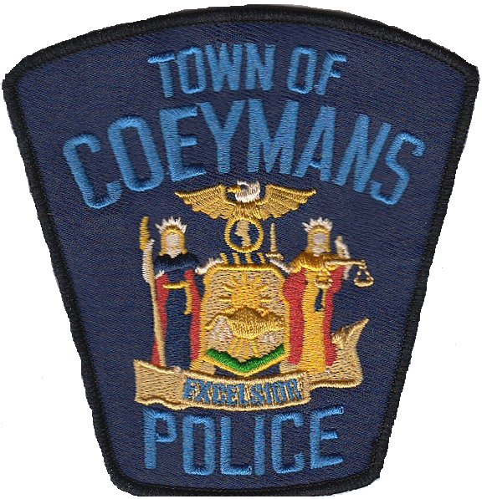

COEYMANS POLICE DEPARTMENT

18 RUSSELL AVE, RAVENA, NY 12143 (518) 756-2059

Citizen Ride-Along Participant Application

Name: (Last, First, Middle) _________________________________________
DOB: ____________________
Place of birth:____________________________________
Home address: ____________________________________________________________________________________________________________________________________________________________
Home Phone: _______________________ Cell Phone: _______________________
E-mail address: _____________________________
Emergency contact information: __________________________________
Agency/School:______________________________
Job Title: _______________________
List any clubs, organizations or organized activities you are involved in.
__________________________________________________________________________________________________________________________________________________________________________________________________________________________________________
Have you ever been arrested? ______
If “yes” above, please provide the date, time, location and disposition of all arrests.
____________________________________________________________________________________________________________________________________________________________
Reason for request: ________________________________________________________________________________________________________________________________________________________________________________________________________________________________________________________________________________________________________________________

ASSUMPTION OF RISK

I, _____________________, reside at ________________ and affirm that I am at least eighteen (18) years of age, and have voluntarily requested to participate in the Ride Along Program of the Town of Coeymans Police Department. I understand the inherent dangers involved in police work and understand that I may be exposed to such dangers, including but not limited to, those risks involved as a passenger inside a marked police vehicle on patrol responding to 911 calls or unexpected occurrences of an emergency or criminal nature. I assume the risk of any and all injuries that may result from my participation in this program.

APPLICANT’S SIGNATURE | DATE
WITNESSED BY | DATE

